Genetic Engineering Challenge
– How can scientists develop a type of rice that could prevent vitamin A deficiency?

To preserve our vision and maintain a healthy immune system, we need to consume vitamin A or pro-vitamin A. Pro-vitamin A is a molecule that our bodies can easily convert to vitamin A. Some plant foods (e.g. carrots and sweet potatoes) are good sources of pro-vitamin A. Some animal foods (e.g. liver and eggs) are good sources of vitamin A.

Around the world, many poor children with inadequate diets suffer from vitamin A deficiency. This results in blindness, severe infectious diseases, and even death for hundreds of thousands of children each year. In this activity, you will learn about one approach to preventing vitamin A deficiency for the many children who eat mostly rice.

White rice is the part of the rice seed that contains starch and storage proteins. Brown rice includes white rice, the germ (which is the embryo that can grow into a new rice plant), and the surrounding bran layers.  Rice is a good source of starch for energy and also provides some protein. However, neither white rice nor brown rice contains pro-vitamin A or vitamin A.  1. Why do rice plants include starch and protein in their seeds? What is the benefit for the rice plants? | 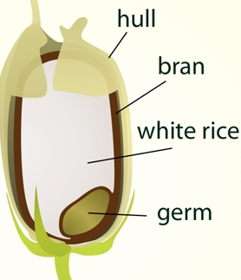  The parts of a rice seed.

2. Why are children who eat mostly rice and little else likely to be vitamin A deficient?

Scientists have used genetic engineering to develop rice plants that have pro-vitamin A in their rice grains. Genetic engineering uses molecular techniques to add or change one or more genes in order to produce desired characteristics. Rice grains are the individual pieces of white rice.

3. Genes provide the instructions to make proteins. Vitamin A and pro-vitamin A are not proteins. What type of gene or genes would scientists need to insert in the rice plant’s cells so the rice grains would contain pro-vitamin A? (Hint: Some plant cells can make pro-vitamin A from smaller molecules that are available in rice plants.)

Scientists have identified genes for two enzymes that can produce pro-vitamin A. One of these genes comes from corn plants.  If the gene from corn plants is inserted in the DNA of the cells of a rice plant, the rice plant will produce the same protein enzyme as the corn plants produce. In other words, the sequence of amino acids will be the same in the protein enzymes produced by rice plant cells and by corn plant cells. | 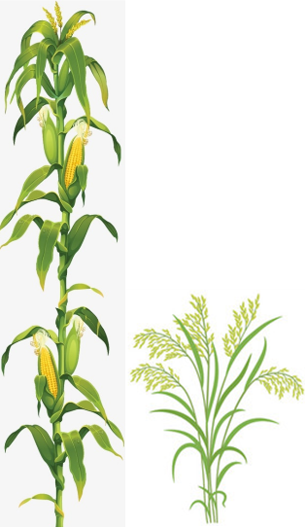

4a. To summarize how the sequence of nucleotides in a gene determines the sequence of amino acids in a protein, write the names of the molecules in the blanks and the names of the processes in the boxes.  4b. What do biologists mean when they say the genetic code is universal? | 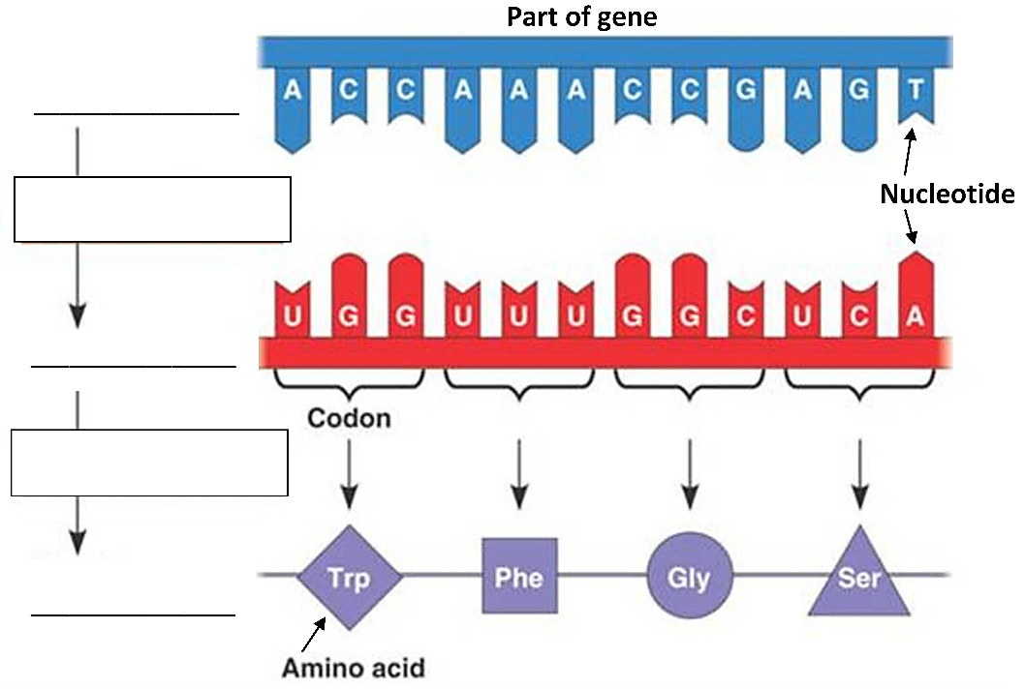

5a. Once scientists have identified the genes for enzymes to produce provitamin A, how could they insert these genes in the DNA of rice plant cells? Suggest one possibility. Be inventive!

5b. Would you recommend that scientists try to insert the genes for enzymes to produce pro-vitamin A into:
___ all the cells in a rice plant or
___ the thousands of cells in each rice grain or
___ a rice plant cell that can divide and develop into a rice plant?

5c. Explain your reasoning.

Inserting the Desired Genes in the DNA of Rice Plants
To insert genes from one organism into a different organism, scientists often use the natural genetic engineering capabilities of a type of bacteria. These bacteria genetically engineer plant cells by inserting part of their bacterial DNA into the plant cell DNA. The inserted genes give the instructions to make proteins that:
- cause the genetically engineered plant cells to produce food molecules that the bacteria can use, but the plant cannot, and
- stimulate these genetically engineered plant cells to divide so there are lots of these cells.

6. Explain how this type of genetic engineering is useful for the bacteria.

The figure below shows how a bacterium inserts some of its genes into the plant cell DNA.
- The plasmid is a small circle of DNA in the bacterium, separate from the main bacterial chromosome.
- Only the T-DNA from the plasmid is inserted into the DNA in the nucleus of the plant cell. The genes in the T-DNA code for the proteins that produce food molecules for the bacteria and the proteins that stimulate increased cell division.

7. The T-DNA begins in the bacterial plasmid and ends up in the DNA of the plant cell. Circle the part of the drawing that shows how the T-DNA moves from the bacterial plasmid to the plant cell nucleus. | 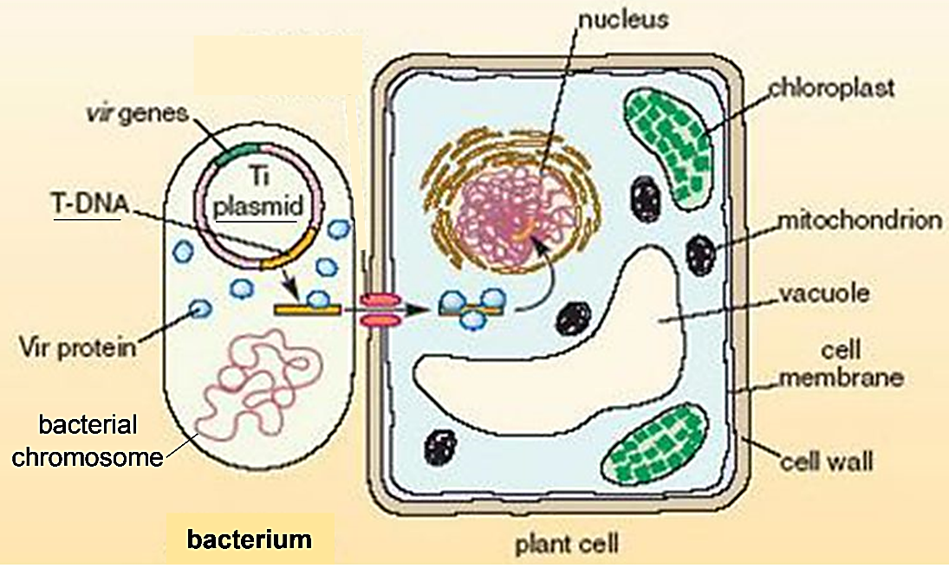

8a. If a scientist wants to use the genetic engineering capabilities of these bacteria to carry the genes for the enzymes to make pro-vitamin A into a plant cell nucleus, where should she insert the genes for these enzymes? Use an arrow to | 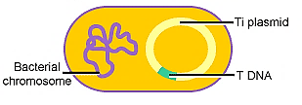
indicate specifically where these genes should be inserted in the bacterium.

8b. Explain your reasoning.

This figure shows the basic sequence of steps that scientists used to make the genetically engineered rice plants that produce pro-vitamin A in their rice grains. In steps 1-3, the scientists used molecular biology techniques to get the desired genes into a bacterial plasmid. Then they used the bacterium’s natural genetic engineering ability to get the desired genes into the DNA of a plant cell.
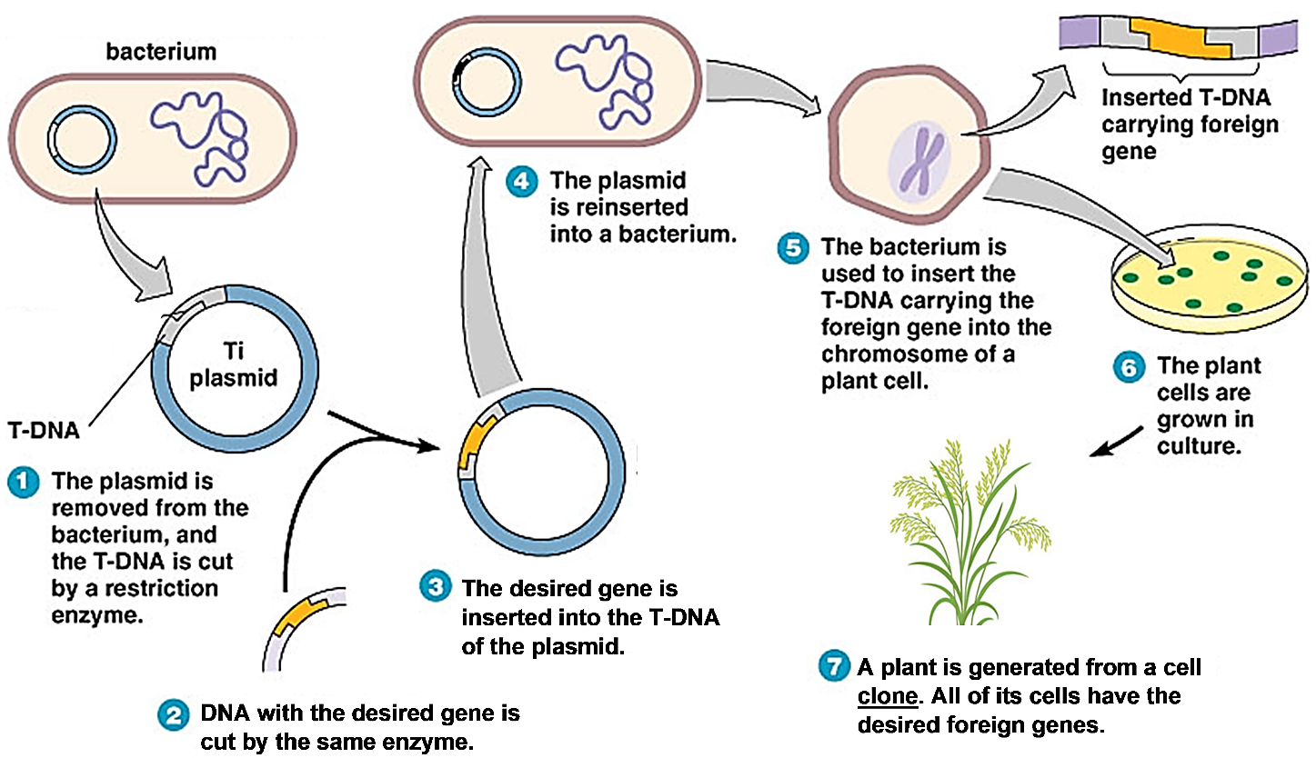

9. Once the desired genes were in a plant cell, how did these genes get into every cell in the plant shown in step 7 in the figure? (Hint: A clone is produced from a single cell by mitosis.)

Ensuring that the Genes for the Enzymes to Make Pro-Vitamin A are Active in Rice Grain Cells
Different types of cells make different types of proteins. This allows each type of cell to carry out its specialized function. For example, cells in the rice grains make storage proteins which provide nutrition for the developing embryo, whereas cells in the leaves make protein enzymes that make chlorophyll for photosynthesis. If a protein is not needed in a particular type of cell, then the gene for that protein is not transcribed in that type of cell.

10a. Match each type of gene in the top list with the best match from the bottom list.

Genes for enzymes to make chlorophyll ____
Genes for storage proteins ____

- transcribed in rice grain cells, but not in leaf cells
- transcribed in leaf cells, but not in rice grain cells
- not transcribed in rice grain cells or leaf cells

10b. Explain your reasoning.

To ensure that the rice grains will contain pro-vitamin A, the genes for the enzymes to make pro-vitamin A need to be transcribed in the rice grain cells. Plant cells have a rather complex molecular mechanism to regulate the rate of transcription for each gene in each type of cell. A crucial part of this molecular mechanism is the promoter segment of DNA located at the beginning of each gene. For example, the promoter for the gene for a storage protein results in transcription of this gene in rice grain cells, but not in leaf cells.

11a. Scientists inserted a promoter in the T-DNA of the bacterial plasmid. Which promoter do you think would be better to insert at the beginning of the genes for the enzymes to make pro-vitamin A? | 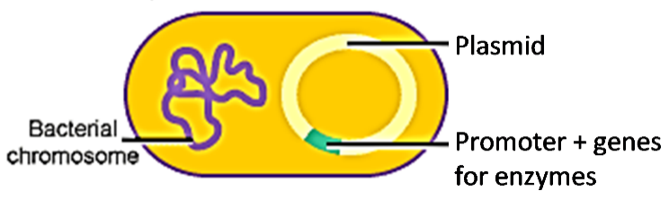
____ the promoter for a gene for an enzyme to make chlorophyll
____ the promoter for a gene for a storage protein

11b. Explain your reasoning.

Genetic engineering has produced a strain of rice called Golden Rice 2, which has substantial amounts of pro-vitamin A in the rice grains. To learn about the controversy concerning Golden Rice, use the following sources:
- “Golden Rice and Vitamin A Deficiency” (https://www.youtube.com/watch?v=9Fg-HxQ5bb0; 12-minute video; 2012)
- “Golden Rice: An Intimate Debate Case” (https://sciencecases.lib.buffalo.edu/files/golden_rice_debate.pdf; read the Introduction, the Pro Golden Rice Handout, and the Con Golden Rice Handout; 2009)
- “Golden Rice Approved as Safe for Consumption in the Philippines” (https://www.smithsonianmag.com/smart-news/golden-rice-approved-safe-consumption-philippines-180973897/; 2020)
- “The Philippines has rated Golden Rice safe, but farmers might not plant it.” (https://theconversation.com/the-philippines-has-rated-golden-rice-safe-but-farmers-might-not-plant-it-129956; 2020).

12. To evaluate the conflicting points of view, first summarize the most important and persuasive points from each source. Then, summarize your conclusions about the role of Golden Rice in the prevention of vitamin A deficiency. Note any questions you have concerning this controversy.

By Dr. Ingrid Waldron, Department of Biology, University of Pennsylvania, © 2021. Teachers are encouraged to copy this Student Handout for classroom use. A Word file (which can be used to prepare a modified version if desired) and Teacher Notes (with background information and instructional suggestions) are available at http://serendipstudio.org/exchange/bioactivities/geneticengineer

